Year 12 Mathematics Extension 2 TRIALS 2006 – Suggested Solutions (LK)

Solutions to Questions | Marking Scheme | Comments
Question 1
(a) 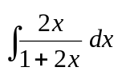 = 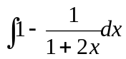  = 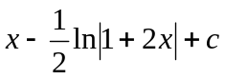 | ❶ for changing the integral  ❶ correct integration
(b) Let the Lee brothers be L₁ and L₂  Let the Abey brothers be A_{1,} A₂ and A_{3.}  Then there are 10 others.  ∴ # possibilities is 365 ways.  ∴ 2 + 60 + 270 + 3 + 30 = 365 [ using 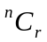] | ❶ for correct answer  ❷ for justification
  L | A | Others
  1 | 0 | 10
  1 | 1 | 9
  1 | 2 | 8
  0 | 1 | 10
  0 | 2 | 9
(c) 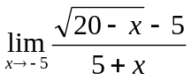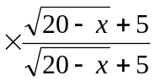  = 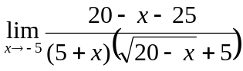  = 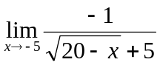  = 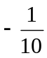 | ❶ for multiplying by conjugate  ❶ correct simplification & answer

Solutions to Questions | Marking Scheme | Comments
Question 1 continued
(d) (1 + z)⁸ = 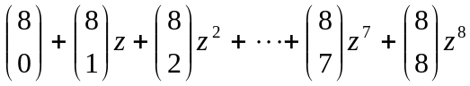  Let z = 1 then 2⁸ = 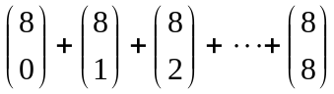  ∴ sum of coefficients = 2⁸ or 256. | ❶ correct expansion  ❶ correct substitution of z = 1 and the correct answer.
(e) 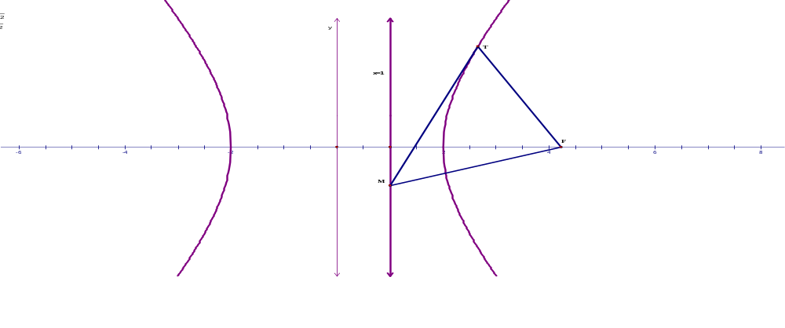  (i) Since 3x² – y² = 12 then we get  6x – 2y = 0 ∴ = 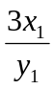 at T.  ∴ equation of tangent: y – y₁ = 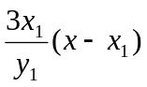  (ii) since this tangent meets the line x = 1  ∴y = 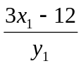 & since F(4, 0)  ∴ FM_{grad} = 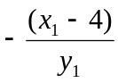 & FT_{grad} = 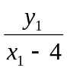  ∴ FM × FT = −1 ∴ FM ⊥ FT. | ❶ correct differential  ❶ gradient at T.  ❶ correct tangent equation  ❶ + ❶ for correct gradients  ❶ correct justification of FM⊥FT.
Solutions to Questions | Marking Scheme | Comments
Question 2
(a)(i) z = 2 cis (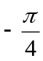)  (ii) z²² = 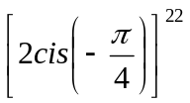 by De Moivre’s Theorem  = 2²²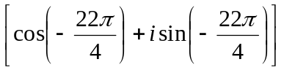  = 2²² 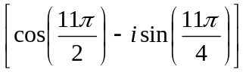  = 2²² (0 – −i) = 2²² i. | ❶ for modulus  ❶ for argument  ❶ correct use of De Moivre’s theorem  ❶ correct simplification  ❶ correct answer
(b)(i) Since a² + b² > 2ab then similiarly  a² + c² > 2ac and b² + c² > 2bc.  ∴ 2(a² + b² + c²) > 2(ab + bc + ac)  ∴ a² + b² + c² > ab + bc + ac as required  (ii) Since a + b + c = 6  Then (a + b + c)² = 36  ∴ a² + b² + c² + 2ab + 2bc + 2ac = 36  But from part (i) a² + b² + c² > ab + bc + ac  ∴ a² + b² + c² + 2ab + 2bc + 2ac> 3(ab + bc + ac)  ∴ 36 > 3(ab + bc + ac)  ∴ ab + bc + ac <12 as required. | ❶ correctly writing the other two inequalities.  ❶ correct inequality  ❶ correct expansion  ❶ correct substitution

Solutions to Questions | Marking Scheme | Comments
Question 2 continued
(c)(i) I_{n} = 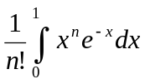, n ≥ 0 By integration by parts  = 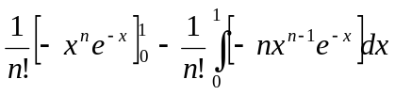  = 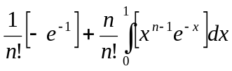  = 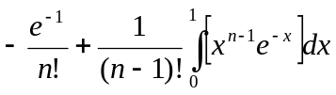  = I_{n – 1} − 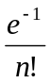 as required.  (ii) I₄ = I₃ − 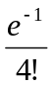 = I₂ − 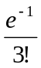−  = I₁ − 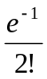−−  = I₀ −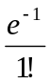− −−  = 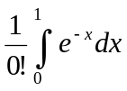−− −−  = 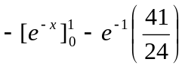  = 1 – 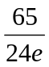 | ❶ + ❶ marks  ❶ mark  ❶ up to this line  ❶ for this line  ❶ correct answer

Solutions to Questions | Marking Scheme | Comments
Question 3
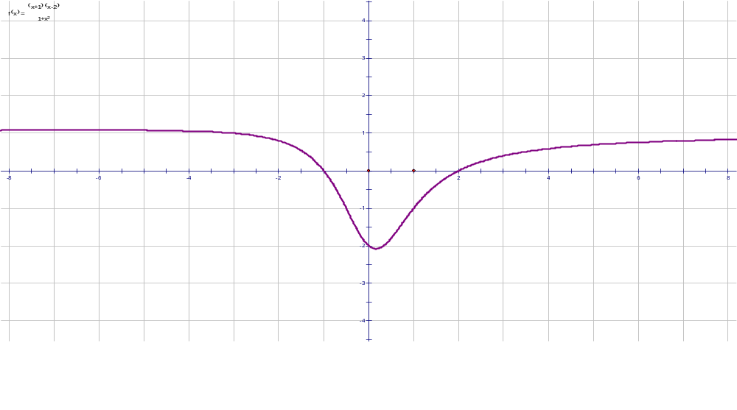  (i) y = |f(x)|  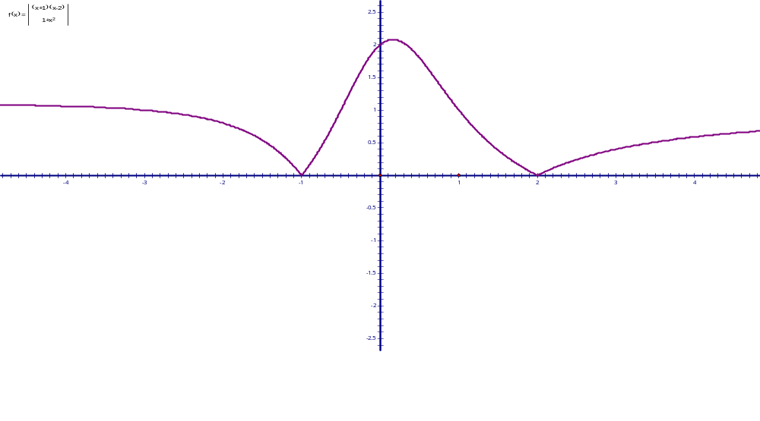 | ❶ shape  ❶ critical points

Solutions to Questions | Marking Scheme | Comments
Question 3 continued
(ii) y = e^{f(x)}  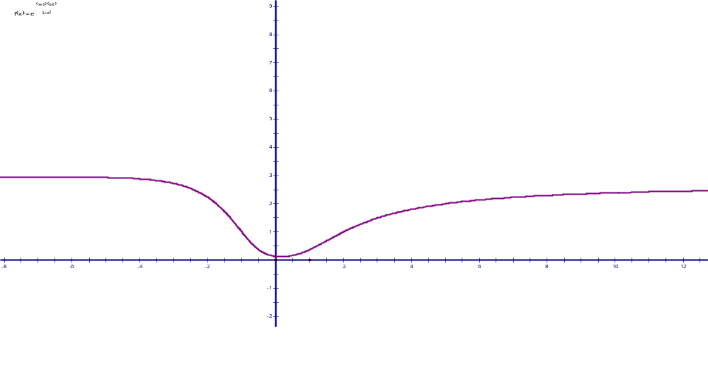  (iii)y = ln(f(x))  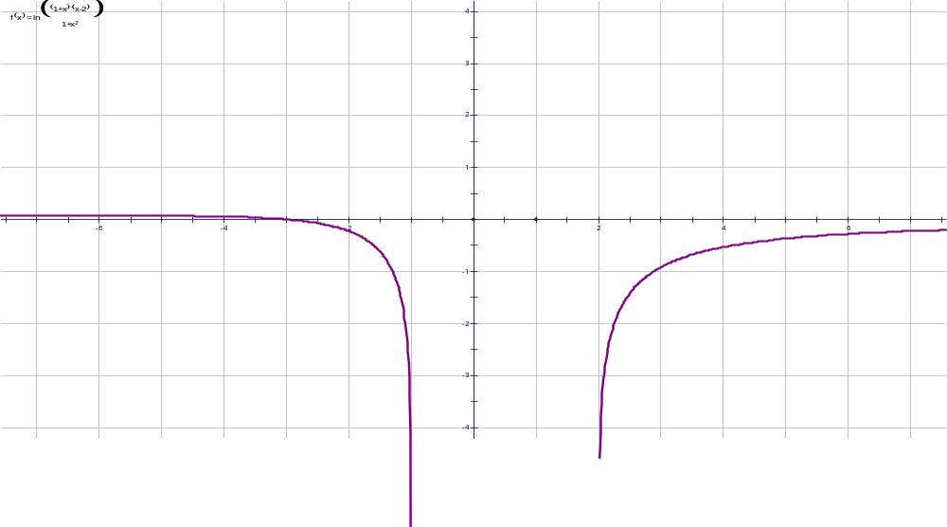 | ❶ shape  ❶ asymptote / turning point  ❶ shape  ❶ x intercept / asymptote
(b) (x² – 5)(x² + 3) over rational field  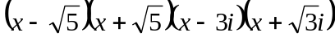 over complex field | ❶ correct factorization  ❶ correct factorisation

Solutions to Questions | Marking Scheme | Comments
Question 3 continued
(c)
(d) 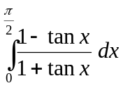 = 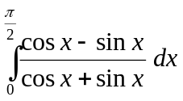  = 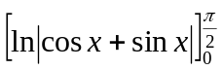  = 0 | ❶ correct conversion to sin & cos  ❶ correct integration + answer

Solutions to Questions | Marking Scheme | Comments
Question 4
(a) T ≤ 20 × 9.8 But T = m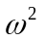r  ∴ mr ≤ 20 × 9.8  ∴ 4 × × ½ ≤ 20 × 9.8  ∴ ≤ 98 rads/ sec  ∴≤ 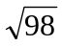× 60 × 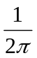 revs / min  ∴ greatest no. of revolutions 94 revs/ min | ❶ T ≤ 20 × 9.8  ❶  ❶ converting to revs/ min & correct answer
(b) 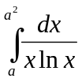 = 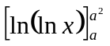  = ln (lna²) – ln(lna)  = 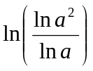  = ln 2 | ❶ correct integration  ❶ correct use of log. Rule  ❶ correct answer
(c) (i) 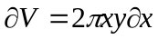  ∴ Total volume = 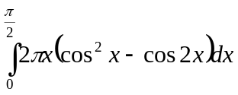  = 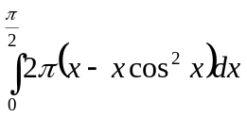  = 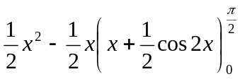  = 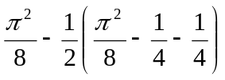  = 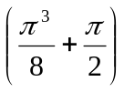 units³ | ❶ showing correct volume of slice  ❶ correct integral + limits  ❶ correct simplified integral  ❶ correct use of IBP  ❶ correct integration by parts  ❶ correct answer in terms of π.
(d) 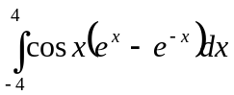  Since cos x is an EVEN function & e^{x} – e^{-x} is an ODD function, EVEN × ODD ➔ ODD  ∴ = 0 | ❶ + ❶ for correct justification  ❶ correct answer | Note: students do not need to physically find the integral!

Solutions to Questions | Marking Scheme | Comments
Question 5
(a) (i) 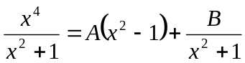  Let x = 0 ➔ B – A = 0  Let x = 1 ➔ ½ = ½ × B  ∴ B = 1 and A = 1  (ii) 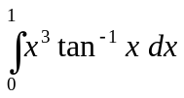  = 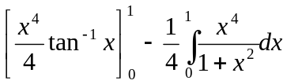  = 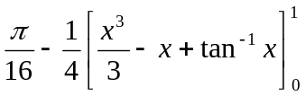  = 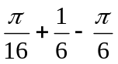  = | ❶ substituting a reasonable x values  ❶ correct answers for A and B.  ❶ + ❶ for integration by parts  ❶ for integration  ❶ substitution  ❶ correct answer

Solutions to Questions | Marking Scheme | Comments
Question 5 continued
(b)(i) particle moving upwards & acceleration is acting downwards ∴ 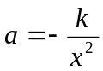  When x = R, a = g  ∴ k = gR².  ∴ 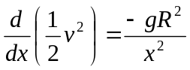 since a = 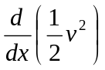  ∴ 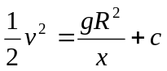  Now when x = R , v = u initially  ∴ c = 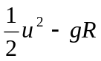  ∴ v² = 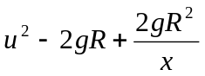  (ii) when u = 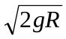 ➔ v² = 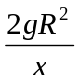  ∴ v = 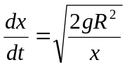, v > 0  ∴ 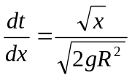  ∴ t = 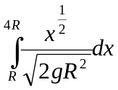 = 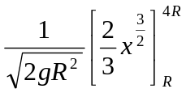  ∴ t = 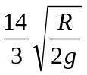 | ❶ for finding k in terms of g and R.  ❶ for finding a in terms of g and R  ❶ integration  ❶ for c  ❶ v² equation  ❶ for 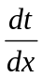  ❶ correct integration for t  ❶ correct answer

Solutions to Questions | Marking Scheme | Comments
Question 6
(a) 4 players  There are ⁴C₁ ways of choosing the team  Then we need four players of the 10: ¹⁰C₄ ways  The 5th player is chosen from the remaining 30 in  ³⁰C₁ way  ∴ total number of ways = ⁴C₁×¹⁰C₄×³⁰C₁ = 25200  5 players ➔ ⁴C₁ ×¹⁰C₅ = 1008 ways  ∴ p(at least 4 players from same team)  = 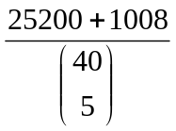= 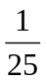 | ❶ correct answer + ❶ justification  ❶ correct answer  ❶ correct probability
(b)
P
Q
S
h
l
T₁
T₂
θ
θ
O
mg

Solutions to Questions | Marking Scheme | Comments
Question 6 continued
(b) (i) By trig. R = lsinθ and h = 2lcosθ.  Resolving forces:  Vertically: 0 = mg + T₂cosθ – T₁cosθ.  ∴ mg = (T₁ – T₂) cosθ. ➔ ①  Horizontally: mr = T₁sinθ + T₂sinθ  ∴ m(lsinθ) = (T₁ + T₂) sinθ. ➔ ②  From ① ➔ T₁ – T₂ = 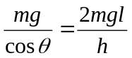  From ② ➔ T₁ + T₂ = ml  ① + ② ➔ T₁ = ml( ½ + 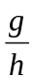) → tension in PQ.  (ii) ② − ① ➔ T₂ = ml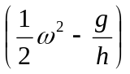  (iii) String PS (hence PQ) will only remain stretched is T₂ > 0 ∴ > 0  ∴ ω > 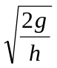  (iv) If T₁ : T₂ = 2 : 1 then 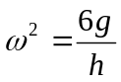  ∴ 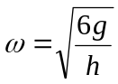 ∴ period of motion = 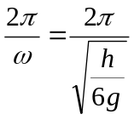 | ❶ sinθ and cosθ relationships  ❶ vertical force  ❶ horizontal force  ❶ rearrangements of equation  ❶ correct addition & simplification  ❶ for answer  ❶ knowing T₂ > 0  ❶ showing answer is true  ❶ getting  ❶ for ω + ❶ period

Solutions to Questions | Marking Scheme |  | Comments
Question 7
(a)(i) α ³+ β ³+ γ ³ = (α + β + γ)³ + 3αβγ  ∴ (α + β + γ)³ + 3αβγ  = (α + β + γ)(α² + β² + γ² −αβ − αγ − βγ) + 3αβγ  = 0 + 3(−q) = −3q  (ii) Let X = 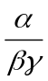= 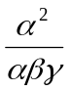= 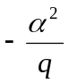  ∴ α² = −qX  But α³ +pα + q = 0 as α is a root  ∴ −qXα + pα + q = 0  (qX – p)α = q  (qX – p)²a² = q²  ∴ (qX – p)²(−qX) = q²  ∴ X(qX – p)² = −q | ❶ correct relationship  ❶ correct expansion  ❶ correct answer  ❶ a² equation  ❶  ❶ correct solution
- (i) ∴ gradient of normal at P is t²  ∴ equation is given by 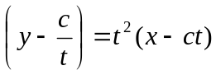  Which leads to the required equation.  (ii) N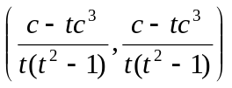  (iii) tan 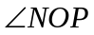= 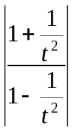 = 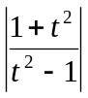 = 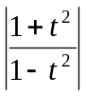  tan 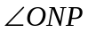= ∴ = | ❶ correct gradient & use of point – gradient formula.  ❶ correct coordinates.  ❶ Finding angles + ❶ conclusion  ∴ ∆ONP is isosceles (equal base angles) |  | Can also show PN = OP
Solutions to Questions |  | Marking Scheme | Comments
Question 7 continued
(c) (i) y = 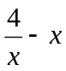  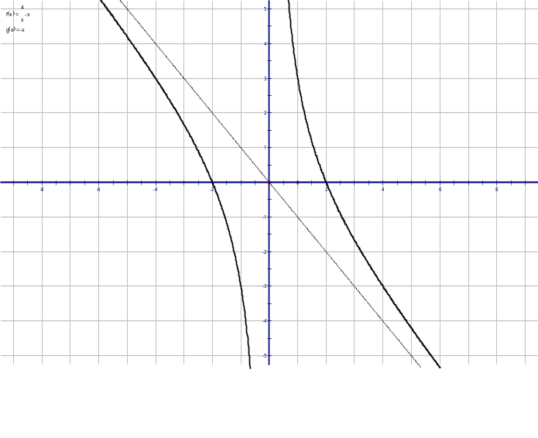  (ii) y = 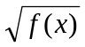  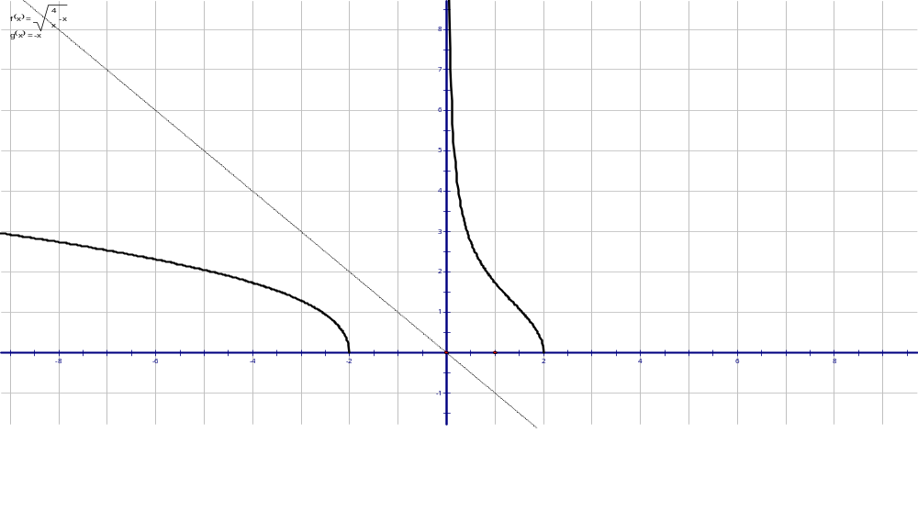 |  | ❶ correct shape  ❶ correct roots & Asymptotes  ❶ + ❶ for each arm
Solutions to Questions |  | Marking Scheme | Comments
Question 8
(a)(i) Since y = 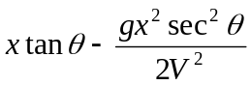 (÷ by gsec²θ / 2V²)  ∴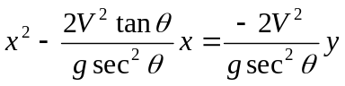  By completing the square:  ∴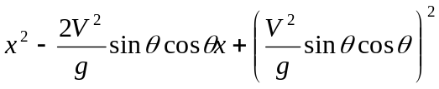  = 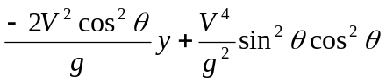  ∴ 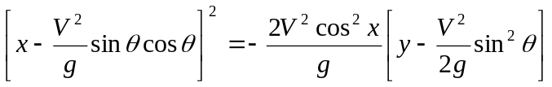  Which is of the form (x – h)² = 4a(y − k).  (ii) The focal length is 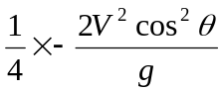 = 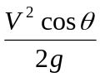  Horizontal range when y = 0  ∴ = 0 ➔ 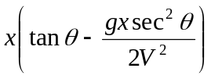 = 0  ∴ ignore x = 0 , then x = 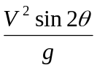∴ since 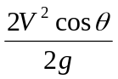= we get cosθ = sin2θ = 2sinθ cosθ ; cosθ ≠ 0  ∴ sinθ = ½ ➔ θ =  |  | ❶  ❶ completing the square  ❶ putting in the form (x – h)² = 4a(y − k).  ❶ focal length  ❶ for RANGE  ❶ answer

Solutions to Questions | Marking Scheme | Comments
Question 8 continued
(b)(i) 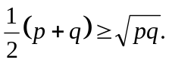  RTP ¼ (p + q)² − pq ≥ 0  LHS = ¼ (p² + 2pq + q² –4 pq)  = ¼ (p – q)² ≥ 0  (ii) now ÷ by 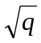 > 0  ➔ 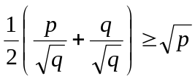  ➔ 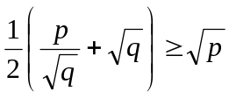 as required | ❶ mark  ❶ mark
(c)(i) see attached

